9.85: In descending a distance d, gravity has done work 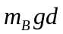 and friction has done work 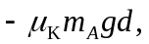 and so the total kinetic energy of the system is 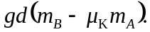 In terms of the speed v of the blocks, the kinetic energy is
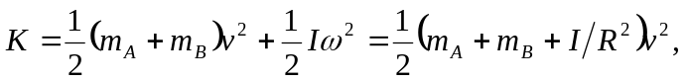
where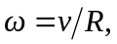 and condition that the rope not slip, have been used. Setting the kinetic energy equal to the work done and solving for the speed v,
